Sprint 3 Report

Scrum Tools, by the Scrum Mates, 3/2/2024

# Actions to stop doing

The team should stop working on the same branches for our tasks because it has resulted in several merging difficulties and extra work staying synced.

# Actions to start doing

The team should start making new branches off of main so that we always have more recent versions of the frontend and the backend. We should also start trying to respond a little sooner to messages on Discord so that team members are not waiting on each other. The team should also start attending the new meetings that we have planned to have so that we have a set time to work together.

# Actions to keep doing

# The team should keep collaborating and using pair programming to work on code. It helps team members who are less familiar with the technologies to learn faster and get more done. The team should also continue to try to have their cameras and mics on during standups because it helps include everyone in the meeting and encourage everyone to give their input.

# Work Completed/Not completed

Completed tasks and stories are crossed out

### Story 1

| **Priority** | **Story** | **Acceptance Criteria** | **SP** |
| --- | --- | --- | --- |
| ~~1 - Must~~ | ~~As a product owner, I want to create new release plans so I can add to previous plans and communicate my plan to the team.~~ | ~~Have a good form for inputting and editing a release plan~~  ~~Be able to create a new release plan based on the current release plan~~  ~~Changes can be saved.~~  ~~Have automatically generated version numbers depending on if a release plan is created fresh, or if it is a revision of a previous release plan.~~  ~~Team can see all versions (previous versions, signed versions, unsigned versions) of the release plan.~~ | ~~5~~ |

| **Tasks** | **Ideal Hours** |
| --- | --- |
| 1. ~~Update the Backlog to fit the design~~ | ~~1~~ |
| 1. ~~Implement the Sanity Check~~ | ~~3~~ |
| 1. ~~Implement the Sprints to fit the design (no functionality yet)~~ | ~~2~~ |
| 1. ~~Have the project name displayed on the Nav Bar~~ | ~~2~~ |
| 1. ~~Allow revision of release plans (create new revision, copy old revision)~~ | ~~2~~ |
| 1. ~~Connect the backend functions to the view release plan (revisions, text boxes)~~ | ~~5~~ |

# Work Completion Rate

Average user stories/day and average ideal work hours/day figures computed across all sprints to date.

Total number of user of stories completed during the prior sprint: 1

Total number of estimated ideal work hours completed during the prior sprint: 15

Total number of days during the prior sprint: 7 days

User Stories/day = 1/7 = 0.143 stories/day

Average user stories/day = avg(0, 0, 0.143) = 0.0476 stories/day

Ideal hours/day = 15/7 = 2.14 ideal hours/day

average ideal hours/day = avg(.86, 1.57, 2.14) = 1.52 ideal hours/day

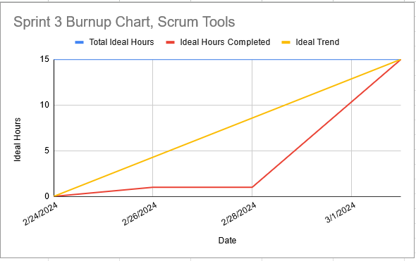

We got off to a slower start than the ideal trend because we had a lot of action items to complete, which did not contribute to the ideal hour count. A lot of team members also did not have time this week to work on the project until the end.

# Completed Scrum Board

